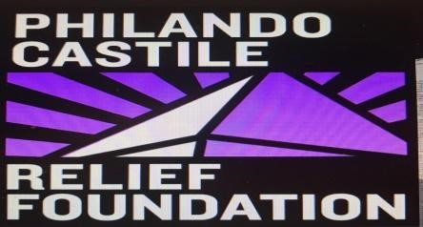

Guidelines and Application

Why was the fund created?
The Philando Castile Relief Fund (PCRF) was created out of the tragic loss of Philando Castile. Philando’s life was tragically and publicly taken in 2016 by a police officer shooting during a traffic stop. At the time, Philando had been working for the St. Paul school district for 15+ years in food nutrition. Because of Philando’s generosity and continued desire to support the children he worked around, it was a natural transition to sustain that generosity to others after his passing. In addition, Philando’s mother and family maintained a desire to not allow his death to be forgotten or seen as another statistical loss to gun violence. The PCRF is another way to keep Philando’s generosity paying itself forward, and assisting other parents that have suffered the loss of a loved one from gun violence.
What is the purpose of the fund?
The purpose of the Philando Castile Relief Fund is to provide immediate assistance to parents who are experiencing loss of a loved one from gun violence. It is during the first moments of experiencing such a tragic loss that parents and families may feel helpless and overwhelmed as they attempt to meet their immediate needs. Philando’s mother and family wanted to be intentional about offering assistance to them during such a time.
What type of relief is given?
The type of relief provided is short-term and immediate. Relief is disbursed in the form of gift cards, with a maximum grant of $400 to eligible applicants. Funds are intended to meet immediate needs for funeral clothing, food and other tangible resources. Relief may also be in the form of connecting applicants to long-term resources and spiritual support.
What criteria must be met?
Relief funds are intended to support parents of loved ones lost by gun violence. There is only one (1) application allotted per household per death. Timeframe of loss must be within Four (4) weeks of request for support/assistance. Max limit of support/assistance $400 (will be provided in various resources). Applicant and lost loved one must be a resident of the Twin Cities.

PCRF P.O. Box 22111 Robbinsdale, MN 55422 Application # _________

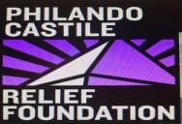
Philando Castile Relief Fund Application

To qualify, you must meet the following requirements:
- The support will focus on assisting parents of children lost by gun violence.
- One (1) application per household per death o Timeframe of loss must be within Four(4) weeks of request for support/assistance o Max limit of support/assistance $400.00 (will be provided in various resources) o Applicant must be a resident of Minneapolis & St. Paul and surrounding suburbs.

Name of Applicant: ___________________________________________________________________
First Middle Last

Phone: ___________________________ Email: ____________________________________________

Address: ____________________________________________________________________________
Number of People in household (including yourself): _________
Employment Status: Employed ____ Disabled_____ Unemployed _____
--------------------------------------------------------------------------------------------------------------------------------------
Lost Loved One Information:
Name: ____________________________________________ D.O.B: ____________ Date of Loss: _________ Funeral Home Name: __________________________________________ Needs:
____ Relief Food for Family ___ Funeral Clothing Assistance ___ Connection to Crisis Services
____ Spiritual support

Applicants Signature: ______________________________________ Date: ______________
Submit Applications to: PCRF, P.O. Box 22111, Robbinsdale MN 55422 or Valeriecastile10@gmail.com
Office Use Only
Application Status □ Approved
V:________ card #:_______ Date GC disbursed :__________
V:________ card #:_______ Date GC disbursed :__________
□ Denied Reason: _________________________

